**ASSIGNMENT NO : 1**

**WRITING PYTHON CODE**

**(HELLO WORLD) ON GOOGLE APP EINGEN**

**NAME : BISMA NAWAL**

**DEPARTMENT OF ELECTRONICS**

**M.PHIL ELECTRONICS (2ND SEMESTER)**

**REGISTRATION NO: 02102313013**

**COURSE: ARTIFICIAT INTELLIGENCE**

**SUBMITTED TO: MAAM MADIHA**

* First search google app engine.
* Creat an account on it.
* Then a dashboard appear on the screen.

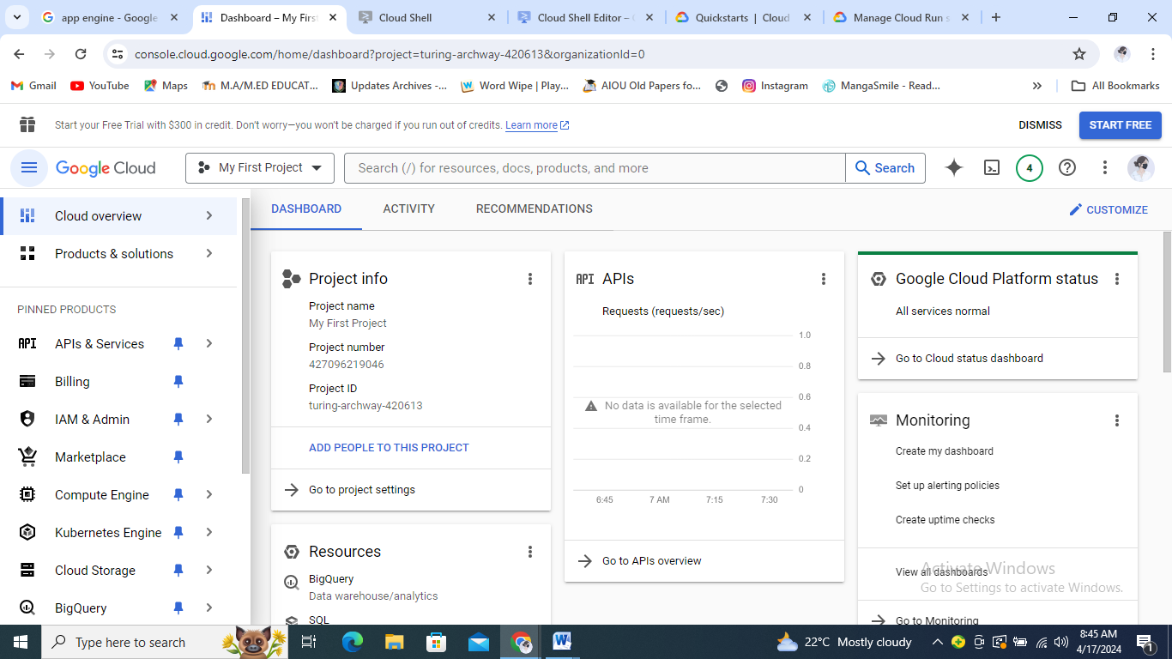

Now select deploy a **hellow world app**

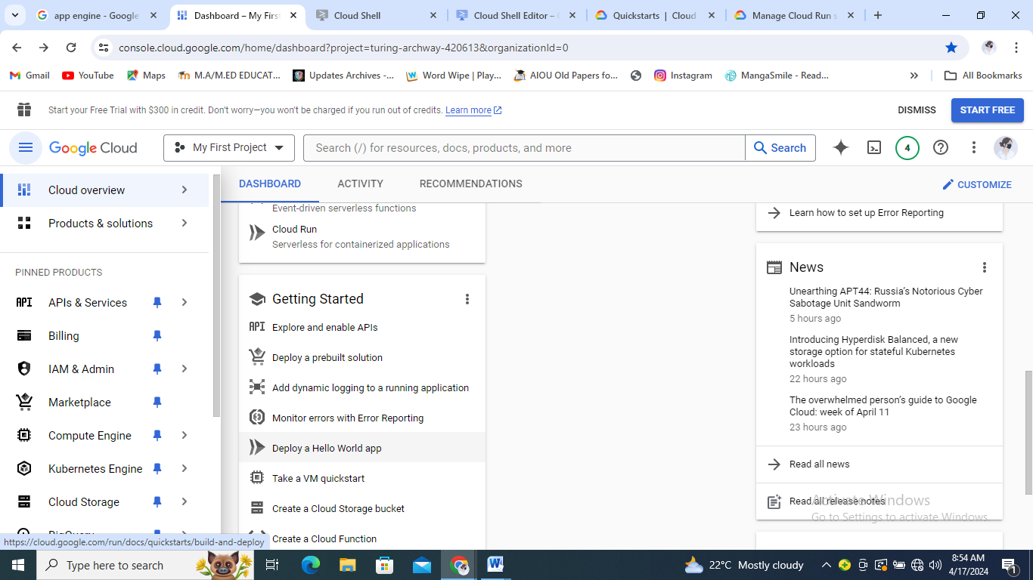

1. Create a new project to ensure that you have the permissions you need, or select an existing project in which you have the relevant permissions
2. Use the following command to enable the required APIs for this tutorial:

gcloud services enable \

run.googleapis.com \

--project=my-project-23-420614

To create a simple web service by using the Cloud Shell Editor

Create a simple web service with Python

1. To open Cloud Shell,

Connecting to your Cloud Shell instance might take a few seconds to complete.

1. When Cloud Shell is ready, click Open Editor.

Connecting to your Cloud Shell Editor might take some time to complete.

1. When the Cloud Shell Editor status bar is available, click Cloud Code, and then do the following:
2. Select New Application.
3. Select **Cloud Run application**.
4. Select **Python (Flask): Cloud Run**
5. In the **Save** dialog, select your home folder, and then click **Create New Application**

# Build and deploy the service to Cloud Run

1. Click Cloud Code, and then select **Deploy to Cloud Run**.

Loading the Deploy to Cloud Run tab might take some time to complete. If the **Authorize Cloud Shell** dialog appears and you agree to the terms, click **Authorize**.

**Writing a python program**

**Print (“hello world”)**

**Output : hello world**

